Email Content

EXPLAINING EARNUP
<Subject> Exciting news, can we touch base?
Name,
ProsperWise has a new partner: EarnUp
With EarnUp you can split a single large monthly loan payment into 2, 3, or 4 “installment” payments, then schedule debits throughout the month to pay them. Such a great budgeting tool!
Added Bonus: Acceleration. When you enroll for a weekly or biweekly program, you make one extra full payment per year.
- Current Monthly = 12 Payments per year
- Biweekly = 26 installments for 13 Full Payments
- Weekly = 52 installments for 13 Full Payments
 | $1,000 Monthly Mortgage Payment
 | Current Monthly Payment | Biweekly Installments
 | 1 x $1000 | 2 x $500
End of year | $12,000 | $13,000

That extra acceleration can shave years and thousands of dollars from your loan. And, you always have the option to add a few extra dollars to your payment.
Use this for your Mortgage, Auto, Student, and other loans.
<insert closing>

STUDENT LOANS
Subject: Student loan payments?
Name,
Our Partner, EarnUp, can help with student loan payments
I talk to a lot of people worried about budgeting for student loan payments. This is both recent grads and parents with kids that have just earned their degree. Medical school loans often surpass $200K!
With EarnUp you can split a single large monthly loan payment into 2, 3, or 4 “installment” payments, then schedule debits throughout the month to pay them. Such a great budgeting tool!
Perfect for student loans
<insert closing>

MORTGAGE LOANS
Subject: Mortgage loan payment strategy that can save you thousand$!
Name,
Our Partner, EarnUp, offers a tool that lets you pay your monthly mortgage payment in smaller installments
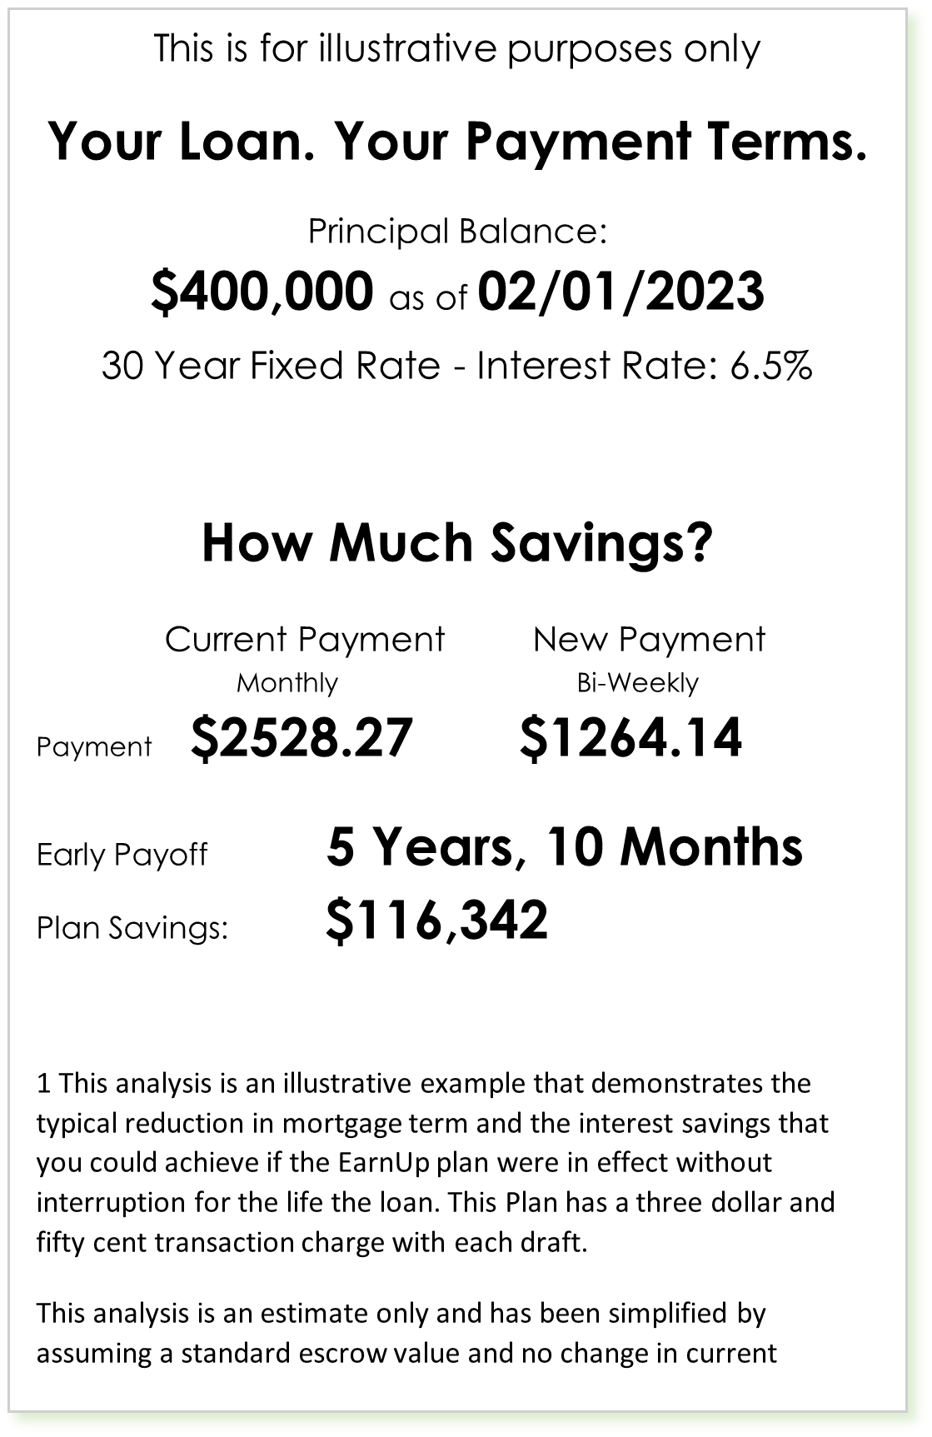
Added Bonus: Acceleration. When you enroll for a weekly or biweekly program, you make one extra full payment per year.
- Current Monthly = 12 Payments per year
- Biweekly = 26 installments for 13 Full Payments
- Weekly = 52 installments for 13 Full Payments
That extra acceleration can shave years and thousands of dollars from your loan. And, you always have the option to add a few extra dollars to your payment.
Take a look at the potential savings on a $400,000 mortgage!

